**Healthier Students at Eisenhower Elementary School**

**James J. Kim**

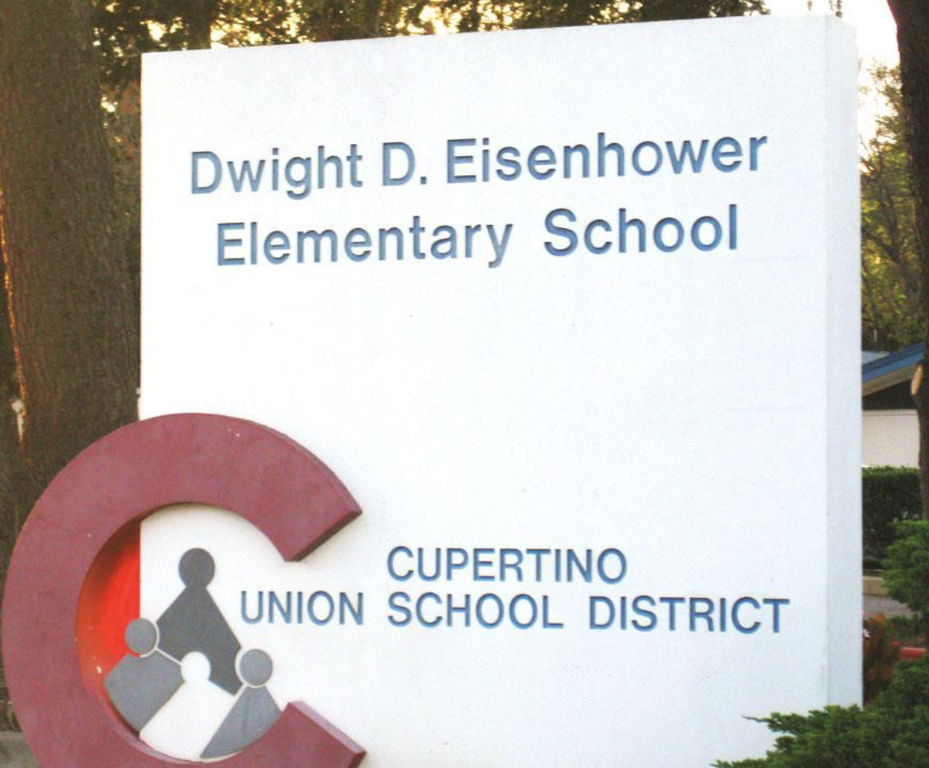One of the primary duty as a parent is to protect our kids and help pave their future. From the moment, our kids come into our lives; we spend countless hours protecting them from any possible harm. As a parent of Eisenhower Elementary School, this too is my goal. Each day we use our best judgment to help steer our kids in the right direction and shield them from any possible danger. But even with our best effort, the threat is closer than it seems. Childhood obesity is a nationwide epidemic but directly affects our kids each day at this school. In a shocking article published in The Lancet in 2010, “every other child in the USA now has a body-mass index (BMI) at or above 85th centile on age-specific national growth charts for ideal weight gain” (The Lancet, 2010). One of the leading contributing factor to childhood obesity is sugar-packed beverages, and it is readily available in kid's daily lunch program. Until we find a healthy alternative, sugar-packed juices are causing our kids to be obese, and their health is in jeopardy. The original lunch program introduced in 1946 was to standardize meal plans and to provide healthily and balance meals for all children attending public school. With the advancement of nutritional science, the program has evolved but hasn't gone far enough. In a study conducted in 2008, The New England Journal of Medicine reports that the kids were eating 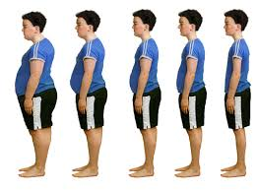far fewer fruits and vegetables and consuming high amounts of refined grains. The study also explains that the kids ate 500 excess calories from solid fats and added sugar per day in school. That is approximately 3500 extra calories per week with the possibly gaining one pound of fat per week, and there are 36 weeks in an academic school year. That is an incredible number of extra calories that our kids are consuming at school. In another article The Role of Sugar-Sweetened Beverage Consumption in Adolescent Obesity: A Review of Literature, author Susan Harrington writes, “56 - 85% of children in school consume at least one soft drink daily. The odds ratio of becoming obese among children increases 1.6 times for each additional can or glass of sugar-sweetened drink consumed beyond their usual daily intake of the beverage” (Journal of School Nursing, 2008). Aforementioned is a startling statistic, and we must seek healthy alternatives for the benefits of our children at Eisenhower Elementary School. If the beverages are known to be one of the primary factors for childhood obesity, we must take a stand and make the necessary changes.

Kevin Garvey (2017) Licensed under kevingarveybroker.com

Nutrition for Health (2015) Licensed Under http://www.newjersey-nutrition.com/childhood-obesity.html

Even with this substantial data, there will be some parents with the different views and beliefs. One of the opposition voices may include just allowing kids to be kids. Some parents may also feel that putting a tighter restriction on their kids doesn't sound appealing and believe that kids will naturally burn off the excess calories. Although all these arguments may appear reasonable on the surface, we are taking a risk by not taking action or even having a conversation. In The Lancet, the study reveals that “children whose BMIs were in the top quartile at the mean age of 11 years were more than twice likely to die before the age of 55” (The Lancet, 2010). This startling statistic means if your child’s body-mass index ranks higher than the average, their life expectancy is affected. That is not okay. The focus should be back on protecting our kids and their well-being and not doing anything shouldn't be an option.

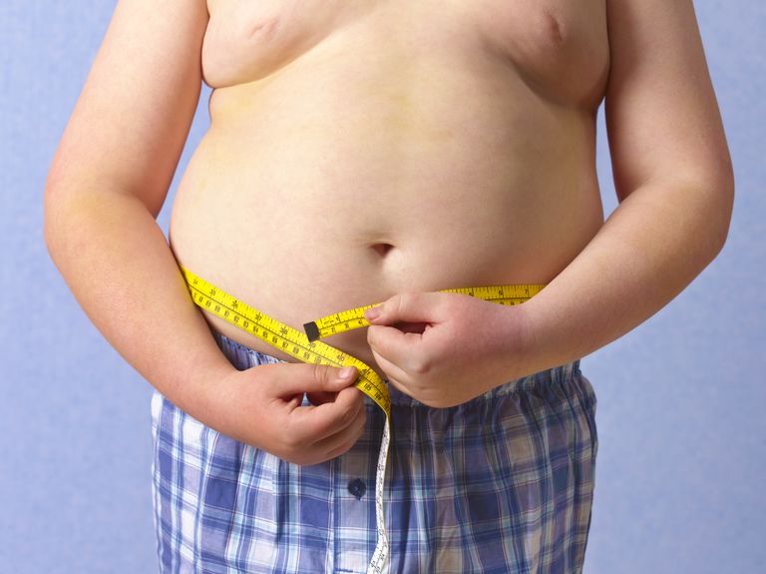 Childhood obesity is a preventable disease, but we are allowing it to affect our kids here at Eisenhower Elementary School. Working together with the school administrators, teachers, parents, and board of directors, we can explore alternative solutions to sugar-packed drinks in our kid’s lunch. We need to start the conversation and bring positive change for our kids. It is time to protect our kids once again and pave a healthier future for our kids.

Peter Dazeley/Getty Images (2017) Licensed Under https://www.verywell.com/childhood-obesity-p2-2632233

References

Carter Robert (2002) The Impact of Public Schools on Childhood Obesity  
 The JAMA Network

Retrieved from

<https://jamanetwork.com/journals/jama/fullarticle/1845186>

Dazely Peter (2017) *childhood-obesity* [Photograph]

Retrieved from

<https://www.verywell.com/childhood-obesity-p2-2632233>

Eagle Taylor F., Gurm Roopa, MS, Goldberg Caren S., MD, DuRussel-Weston Jean, RN, MPH, Kline-Rogers Eva, RN… (2010) *Health status and behavior among middle-school children in a midwest community: What are the underpinnings of childhood obesity?* - American Heart Journal

Retrieved from

<http://www.ahjonline.com/article/S0002-8703(10)00888-4/abstract>

Garvey Kevin (2017) *Eisenhower Elementary School* [Photograph]

Retrieved from

<http://kevingarveybroker.com/IDX/290-Howard-DR-SANTA-CLARA-CA-95051/81455125_REIL/0005610>

Harrington Susan (2008). *The Role of Sugar-Sweetened Beverage Consumption in Adolescent Obesity: A Review of the Literature*. Journal of School Nursing, (24, 3-12)

Retrieved from

<http://web.a.ebscohost.com.ezproxy1.lib.asu.edu/ehost/pdfviewer/pdfviewer?vid=1&sid=00efad5c-2a31-4236-95f7-da7f8f6f71d4%40sessionmgr4009>

Nutrition for Health (2015) *Obesity* [Photograph]

Retrieved from

<http://www.newjersey-nutrition.com/childhood-obesity.html>

The Lancet (2010) Childhood obesity: affecting choices

Retrieved from

<http://www.thelancet.com/journals/lancet/article/PIIS0140-6736(10)60247-4/fulltext>

Woo Baidal Jennifer A., MD, MPH, Taveras Elsie M., MD. MPH (2014) *Protecting Progress against Childhood Obesity — The National School Lunch Program* The New England Journal of Medicine

Retrieved from  
<http://www.nejm.org.ezproxy1.lib.asu.edu/doi/10.1056/NEJMp1409353>